**Assignment 5**

**A)** Create **emp** table with Appropriate Data types, insert data into the table

| **Empid** | **EmpName** | **Department** | **ContactNo** | **EmailId** | **EmpHeadId** |
| --- | --- | --- | --- | --- | --- |
| 101 | Isha | E-101 | 1234567890 | [isha@gmail.com](mailto:isha@gmail.com) | 105 |
| 102 | Priya | E-104 | 1234567890 | [priya@yahoo.com](mailto:priya@yahoo.com) | 103 |
| 103 | Neha | E-101 | 1234567890 | [neha@gmail.com](mailto:neha@gmail.com) | 101 |
| 104 | Rahul | E-102 | 1234567890 | [rahul@yahoo.com](mailto:rahul@yahoo.com) | 105 |
| 105 | Abhishek | E-101 | 1234567890 | [abhishek@gmail.com](mailto:abhishek@gmail.com) | 102 |

1. Update department valueas E-111 for the EmpHeadId-105.

2. Update email ID to [ts123comp@gmail.com](mailto:ts123comp@gmail.com) for Abhishek.

3. Delete the record for Department E-104.

4. Add column City to the emp table.

5. Drop EmpHeadId column from emp table.

6. Rename emp as employees

7. Truncate table employees

8. Drop table employees

9. Drop employees table.

**B)** Create table **customer** with appropriate Data types and Insert following Data

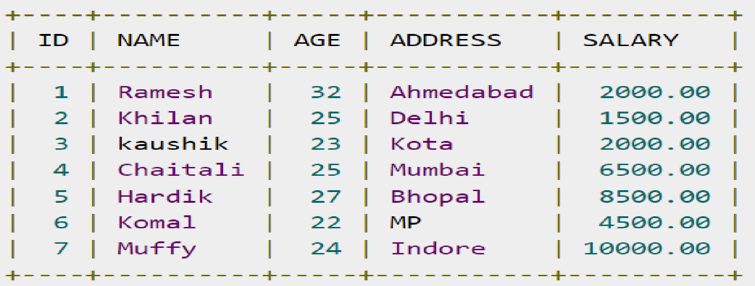

1. Display ID, Name and Salary of all the employees.

2. Change salary of Ramesh to 15000 rupees

3. Change age of muffy to 32 years

4. Add column city.